Microsoft® Money 98

Frequently Asked Questions - Setting up financial products in Microsoft® Money 98

The contents of this document are intended to assist Microsoft Money users with the set-up of UK Financial Products in Microsoft Money and are not intended for the purpose of providing financial advice.
Contents
Important Notice 4
Mortgages 5
Repayment mortgages 5
Interest Only mortgages 5
Investment plans for Interest Only Mortgages 5
Endowment 5
Pension 5
Personal Equity Plans/Individual Savings Accounts 5
Life Assurance 6
Term Assurance 6
Level Term 6
Convertible Term 6
Decreasing Term 6
Family Income Benefit 6
Whole of Life Policies 6
Without Profit 7
With Profits 7
Unit Linked 7
Low Cost Whole of Life 7
Endowments 7
With Profits Endowment 8
Low Cost Endowment 8
Low Start Endowment 8
Unit Linked Endowment 8
Health insurance 9
Permanent Health Insurance 9
Critical Illness Insurance 9
Savings & Investments 9
Unit Trusts 9
Open Ended Investment Companies (OEICs) 10
Investment Trusts 10
Investment Bonds 10
Personal Equity Plans 10
TESSAs 10
Individual Savings Accounts (ISA) 10
Pensions & Annuities 11
Individual Arrangements 11
Section 226 Contracts 12
Personal Pensions 12
Company Pension Schemes 13
Money Purchase Schemes 13
Final Salary Schemes 13
Additional Contributions 13
Additional Voluntary Contributions (AVCs) 14
Free Standing Additional Voluntary Contributions (FSAVCs) 14
Pension Transfers 14
Annuities 14
Single Life Annuity 15
Joint Life Annuity 15
Guaranteed Period 15
Level 15
Increasing 15
Reduced on first death 15
Stock Market Overview 15
The Risk Involved 15
What is a Stock Broker? 16
Inputting Financial Data Into Money 17
Overview 17
Golden Rules 17
With Profits Endowments 18
Unit Linked Endowments 21
Low Cost Whole of Life 33
Unit Linked Whole Of Life 36
Term Assurance Policies 37
Mortgage Protection & Decreasing Term Policies 37
Family Income Benefit 37
Permanent Health Insurance 37
Unit Trusts/ OEICs 39
Personal Equity Plans 43
PEP With Unit Trust Option Selected 46
PEP With PEP Option Selected 46
A Guide to some of the language used within PEP and Unit Trust statements 50
Single Premium Investments 51
Pensions And Set Up Of Paycheque In Bills 51
TESSAs 59
Stock & Shares 59

Important Notice

Present information is based upon sound financial principles but does not endorse any specific financial strategy. We urge you to consult with a Professional Financial Adviser before making any important decisions about your finances.

You should satisfy yourself as to the suitability of any investment, including its cost, your ability to access the capital when you need it and the element of risk involved before entering into any commitment.

Any statement within this document regarding tax liability is based on legislation and tax practices as at October 19th 1998 which is of course, subject to change.

Where information is provided on financial products it is based on our current understanding.

Where a product has an underlying investment content, in many cases the value of the investment, and any income from it, can fall as well as rise.

Past performance is no guarantee of future performance.

Where mortgages are mentioned do remember that your home is at risk if you do not keep up repayments on a mortgage or other loans secured on it. All mortgages are subject to underwriting, status and are not available for persons under the age of 18.

Copyright 1998 Microsoft Ltd. All rights reserved. Microsoft Ltd, Thames Valley Park, Reading RG6 1WG.

Mortgages

Often the purchase of your home is the largest financial decision taken in life. A mortgage is a loan from a lender, usually a bank or building society, which needs to be repaid over a chosen period, typically 25 years. It is important that you understand the types of mortgages available.
In the UK there are two types of mortgage available - Interest Only mortgages and Repayment mortgages.

Repayment mortgages

Monthly payments are given to the lender which are made up of interest charged on the amount borrowed and a capital repayment. As the capital is gradually repaid each month, the outstanding debt is reduced. At the end of the term it is guaranteed that the amount borrowed is repaid in full.
Additionally a term assurance policy needs to be taken out to repay the mortgage in the event of the borrower’s premature death.

Interest Only mortgages

With an ever increasing awareness of the long term investment returns provided by the stock markets around the world, interest only mortgages have become increasingly popular. Monthly payments are made to the lender, to pay the interest due. The amount borrowed from the lender remains outstanding for the duration of the term. At the end of the term the amount borrowed must be repaid in one lump sum. We explain below some of the methods that can used to repay the amount borrowed.

Investment plans for Interest Only Mortgages

The outstanding interest on an interest only mortgage is paid monthly to the lender.

Endowment

An endowment policy can be taken out with an insurance company with the intention of providing a lump sum which will hopefully be enough to pay off the outstanding capital of the mortgage at the end of the term. Endowments provide life assurance to ensure that the mortgage can be paid off in the event of death. Many endowments offer additional benefits such as critical illness cover and waiver of premium benefit.

Pension

Using pension policies as a means of repaying a mortgage started in the 1970s. Since this time the Inland Revenue has made it clear that pension policies should primarily be used for retirement planning. If a person is considering using a pension policy to repay a mortgage, they need to ensure they have made sufficient plans to fund for their retirement.

Basically, regular premiums are paid into a pension policy and the tax free lump sum available from the policyholder’s 50th birthday can be used to repay the mortgage. Additionally a term assurance policy needs to be taken out, possibly pension term assurance, to repay the mortgage in the event of the borrower’s premature death.

Personal Equity Plans/Individual Savings Accounts

Personal Equity Plans (PEPs) are a tax efficient way to save. Many people use the benefits of a PEP to build up a lump sum with the intention of repaying their mortgages at the end of the term or earlier if possible.

PEP/ISA products are one of the cheapest and most flexible forms of repaying an interest only mortgage but they can be higher risk than endowment and pension policies. A level term life assurance policy will be necessary to protect against death.

PEPs will no longer be able to be set up after April 6th 1999 as they are being replaced by Individual Savings Accounts (ISAs). However, any PEP investments already accumulated will be able to remain within the PEP.

Life Assurance

There are various types of life assurance available. A life assurance plan will pay out on the death of the life assured. The most appropriate type of life assurance depends on a person’s needs and priorities.

Term Assurance

Term assurance, as the name implies offers life cover for a given period. It is the oldest, simplest and cheapest type of life assurance. There are several types available:

Level Term

The life cover payable on death remains unchanged throughout the term of the policy. This type of plan never acquires a value and only pays out upon death. A level term policy would be best entered into Money as an asset as long you aware the policy will never have a value.

Convertible Term

This is a level term assurance policy with an option to convert the policy at any time to a permanent assurance i.e. to an endowment or whole of life policy, without providing any further evidence of health. Renewable term assurance is similar although an exchange of the original term assurance can only be for another term assurance at the end of the term.

This type of policy would be best entered into Money as an asset.

Decreasing Term

This is the cheapest form of life cover. The death benefit decreases over the term of the policy. It is generally used to cover a reducing debt, such as a mortgage or bank loan. Although the death benefit eventually reduces to zero, the premiums remain constant.

This type of policy would be best entered into Money as an asset.

Family Income Benefit

Technically, Family Income Benefit policies are decreasing term assurance policies which pay out a regular income in the event of death of the life assured until the end of the term. They are used predominantly to protect families with young children.

This type of plan would be best entered into Money as an asset.

Whole of Life Policies

A whole of life policy guarantees to pay the death benefit on the death of the life assured, whenever it occurs.

Below are the main types of whole of life policy:

Without Profit

Without profit policies provide a guaranteed sum assured at death. The amount chosen at the start remains unchanged throughout the policy’s life. These policies are very rarely recommended these days as the effects of inflation erode the value of benefit offered by the policies. The best way to set this policy up in Money would be as an asset as long you are aware the policy will never have a value.

With Profits

A with profits policy offers a guaranteed sum assured at death. They also share in the profits of the life fund of the provider company. These profits are paid to policyholders in the form of bonuses. A reversionary bonus which once declared cannot be taken away is added to the value of the sum assured. A terminal bonus may be payable at the same time as the guaranteed sum assured. Reversionary bonuses are declared once a year and bonus declarations are sent out to all policy holders.

Unit Linked

Unit linked policy returns are linked to the value of the units in an investment fund managed by a life assurance company. The fund will invest in assets which will rise and fall. The price of units will correspondingly rise and fall. Unit linked policies are therefore not guaranteed.

Most unit linked whole of life policies are flexible and offer a choice between minimum and maximum cover for the same regular premium. The policy holder can choose the proportion of the premium which pays for life cover and the proportion that goes into savings, although other unit linked savings policies may be more appropriate for savings. Whole of life policies are designed primarily to provide life cover.

Unit linked policies can be tracked as a share/stock account, either daily/weekly from the press or upon receipt of the policy statement.

Low Cost Whole of Life

Low cost whole of life policies are an alternative to a traditional with profits policy as they are cheaper. The cost saving is achieved by combining a with profits whole of life policy with decreasing term assurance. Within the with profits part of the policy, bonuses are added to the sum assured.

If death occurs in the early years the decreasing term assurance pays out. If the policy continues for several years the decreasing term reduces to a nil value and the sum assured with its attaching bonuses takes over.

Endowments

Endowment policies are the most expensive type of life assurance. They are primarily savings plans with life assurance built in. The policies are set up on a fixed term, the minimum being 10 years and can continue until the life assured reaches a certain age such as 85. Endowments pay out on a given date or on earlier death with the proceeds usually free of tax in the hands of the policy holder. The principal aim of an endowment is to build up a lump sum. Endowments are commonly used for ‘interest only’ mortgages, education funding and general long term savings.

There are endowments available called Maximum Investment Plans which are set up for a 10 year term with the sole intention of providing a savings vehicle to produce a tax efficient lump sum at maturity.

Endowments can be without profit, with profit or unit linked, although without profit endowments are becoming less common in today’s market place as they do not protect against inflation.

Endowments, like most life assurance policies can be ‘qualifying’ or ‘non-qualifying’ for tax purposes. In simple terms , if you are a higher rate tax payer you could be liable to tax on any gain from a ‘non-qualifying’ life assurance policy. There are complex rules as to what makes a life assurance policy qualifying or not. Endowments are in the main set up as ‘qualifying’. An insurance company or a financial adviser can give you further information if you are interested.

With Profits Endowment

A with profits endowment offers a guaranteed sum assured which is increased by bonuses. Bonuses are declared by the provider of the endowment once the profits of the with profits fund have been calculated (see whole of life with profits section). The policy holder chooses the guaranteed sum assured needed at the maturity date, perhaps to repay a loan. At the maturity date the bonuses attaching to the policy are generally surplus to needs and are paid to the policy holder who does not need to pay any tax on the cash received.

The best way to set this policy up in Money would be as an asset.

Low Cost Endowment

This type of endowment is ideal for ‘interest only’ mortgage repayment. Low cost endowments combine a with profits endowment with a decreasing term assurance . The aim of the policy is to use the bonuses added to the sum assured to give the policy holder a lump sum at the end of the term - the maturity date. There is a guaranteed sum assured payable on death (usually equal to a mortgage amount) and a basic sum assured plus bonuses. On death the greater of the two amounts is paid. If death occurs in the early years the decreasing term assurance pays out. If the policy continues for several years the decreasing term reduces to a nil value and the sum assured with its attaching bonuses takes over.

As the basic sum assured is set at a lower level than for a traditional endowment premiums are cheaper.

The best way to set enter this type of policy in Money would be as an asset.

Low Start Endowment

A low start endowment is a low cost endowment policy where the premiums in the early years are set at a lower than normal level and then increase by a set percentage for a set number of years. For example, the premium may increase by 10% for the first five years and then remain at the same level for the remainder of the term. At the end of the 5 years the premium is higher than it would be on a level premium low cost endowment.

The best way to set enter this type of policy in Money would be as an asset.

Unit Linked Endowment

Premiums paid into a unit linked endowment are used to buy units in the investment funds of a life assurance company. Units are then cashed in to pay for the life cover provided by the policy.
The benefits provided by a unit linked endowment on death or maturity are the greater of the guaranteed sum assured or the cash value of the units at their sale price.

As this policy is unit linked it can be tracked as a share/stock account, either daily/weekly from the press or annually upon receipt of the policy statement.

Health insurance

There are a number of different types of health insurance available. New policies are being developed constantly in order to meet the increasing needs of the UK public who are living longer and wanting access to more advanced health care.

Some of the following health policies can be added to life assurance policies as an additional benefit.

Permanent Health Insurance

Permanent Health Insurance (PHI) pays an income benefit to the policy holder when he or she is unable to work due to sickness or accident after a deferred period of time, for example, three months. The income benefit is a regular income, usually paid monthly to replace up to 50 - 60% of the income that could have been earned by the insured minus state benefits. Providers of PHI offer different definitions for someone to be able to claim.

Generally the insured must demonstrate that he or she is unable, by reason of sickness or accident, to follow his or her own occupation or any other for which they are suited.

Other than to input the premiums into “Bills” it is not recommended that you attempt to track this policy in Money.

Critical Illness Insurance

This type of insurance pays a lump sum upon diagnosis of a critical illness such as heart attack, stroke or cancer. Many people who are diagnosed as contracting a critical illness may live for many years but may be unable to continue working. This is when payment of a sum of money can be very beneficial. A critical illness policy is similar to a life assurance policy but pays out only on diagnosis of a defined critical illness.

Other than to input the premiums into “Bills” it is not recommended that you attempt to track this policy in Money.

Savings & Investments

Savings and Investment products can range from a bank or building society deposit account, a National Savings product available from the Post Office, through to investment in equities via the Stock Market. There are thousands of different savings and investment products available. Where money is invested will depend on the investor’s attitude to risk and the amount of money available.

People save and invest to provide them with income and/or capital growth. In the UK collective investment schemes are popular. These are simply an investment where lots of people invest at the same time and their money is 'pooled' together.

The following selection gives a quick overview of the merits of different investments available.

Unit Trusts

A Unit Trust ‘pools’ together the investments of many people to create a fund which invests in a wide range of investments within the range allowable by the trust.

Investors buy units as the trust is divided into units, each one of which represents an equal share in the trust's assets. The value of the units will fluctuate as the value of the fund changes. Units are bought at the offer price which is higher than the selling price known as the bid price.

Direct investment into Unit Trusts should be tracked as a Unit Trust.

Open Ended Investment Companies (OEICs)

OEICS are collective investment schemes which have only been available in the UK since 1996. They are similar to unit trusts in their investment activities but are expected to replace unit trusts. They are set up as legal companies and offer similar investment choices and taxation benefits as unit trusts do.

Direct investment into OEICs should be tracked as a Unit Trust.

Investment Trusts

Investment Trusts are the oldest form of collective investment in the UK. They are public limited companies which invest in the shares of other companies to make a profit for its own shareholders.

Direct investment into investment trusts should be tracked as a share.

Investment Bonds

Investment bonds, also called unit linked bonds or single premium bonds, are a lump sum investment often written on a whole of life basis.

If the bond is unit linked there is normally a broad range of investment funds to choose from including managed funds, general funds and specialist funds.

There are many types of bonds available such as guaranteed income or growth bonds, fixed interest bonds and with profit bonds. It is usually possible to cash in all or part of the bond at any time, or take regular withdrawals.

Personal Equity Plans

Personal Equity Plans (PEPs) are savings and investment plans with special tax exemptions. The underlying investments in a PEP can be one or more of many things from unit trusts, OEICs and investment trusts through to stocks and shares.

A UK resident can invest up to £6,000 into a General PEP each tax year, monthly annually or with sporadic lump sums. The growth and income from a PEP will be tax free and there is no need to mention PEPs on tax returns.

New PEPs will no longer be available after 6th April 1999 when Individual Savings Accounts will replace them. However existing PEPs can continue, but no further investments can be paid into them after 6th April 1999. See the ISA section for further information.

TESSAs

Tax Exempt Special Savings Accounts (TESSAs) are deposit accounts offered by Banks or Building Societies. As the name denotes all interest on the account can be tax free. The term for investment is 5 years with the maximum deposit being £1,800 each year. However, up to £3,000 may be invested in the first year with a corresponding reduction in the final year’s deposit.

New TESSAs will no longer be available after 6th April 1999 when Individual Savings Accounts will replace them. If a TESSA is set up before 6th April it can run for its full 5 year term. See the ISA section for further information.

Individual Savings Accounts (ISA)

Individual Savings Accounts (ISAs) will replace PEPs and TESSAs from 6th April 1999. ISAs may consist of up to three separate elements:
Investment For example, Unit trusts, investment trusts, Gilts and Open Ended Investment
Companies (OEICs).
Cash For example, Bank and building society accounts, National Savings and cash
unit trusts.
Life assurance For example, Savings products which offer life cover as a benefit.

Investment limits
First year of ISA  (6th April 1999 to 5th April 2000) | Future tax years (6th April 2000 onwards)
Investment ISA Up to £7,000 | Up to £5,000
Cash ISA Up to £3,000 | Up to £1,000
Life Assurance ISA Up to £1,000 | Up to £1,000
Combined maximum £7,000 | £5,000

ISAs will not be actually approved by the government but there will be benchmarks set by the government to provide assistance to investors when choosing an ISA. They will cover Cost, Access and Terms and will be known as the 'CAT' standards.

There will be three sets of ‘CAT’ standards, one for each element of the ISA.

The value of your current PEPs will not affect the amount that you can invest in an ISA. All PEPs held at 5th April 1999 can continue to be held as PEPs, with the same tax advantages as an ISA but no new PEP investments can be made after 6th April 1999. No limit has been imposed on the total value of any PEP portfolio.

Any TESSA taken out before 6th April 1999 will be allowed to run for the full five-year term. On maturity, capital from a TESSA can be transferred into an ISA without counting against the annual ISA subscription limits.

Pensions & Annuities

A pension arrangement is simply a plan or scheme into which money is paid during an individual’s working life, which is then used to provide a regular income once that person stops working or retires.

The arrangement into which the money is paid will either be a pension scheme arranged by an employer, or a pension plan set up by the individual. When the individual starts drawing income during their retirement this is usually arranged by the purchase of an annuity with the proceeds of the pension arrangement. This income will then continue until the individual dies, but can also be set up so that an income continues to be paid to the deceased spouse or dependants.

There are many different types of pension arrangement available, although the main types can be split into either individual arrangements and employer sponsored schemes. However they all share the fact that they offer a tax efficient way to save for retirement.

Most pension arrangements are set up as investment contracts, which can be either With Profits or Unit Linked.

Individual Arrangements

These are pension contracts for the self-employed and also for employees that are not members of an employer sponsored pension scheme. There are several types of individual arrangement as detailed below:

Section 226 Contracts

These are also known as Retirement Annuities Contracts and were the precursors for Personal Pensions. Such contracts were the usual investment vehicles for those individuals who were planning their retirement. If someone was self employed or an employee whose employer did not provide a company pension scheme then any pension plan taken out before July 1988 will almost certainly have been a Retirement Annuity Contract. It is no longer possible to take out a new Section 226 Contract, but if one already exists premiums into it can continue.

Other than slightly different contribution limits and tax free cash rules (Up to 30% of the fund may be available as tax free cash for Section 226, compared to a maximum of 25% for Personal Pensions) Retirement Annuities are similar to Personal Pension Plans. Both types of contract benefit from tax relief on premiums, grow within a tax advantaged fund, and provide tax free cash plus a pension income which is taxed.

Retirement Annuity / 226 contracts contribution limits
Age at start of tax year | % Net Relevant Earnings*
50 or less | 17.5%
51-55 | 20%
56-60 | 22.5%
61-74 | 27.5%

*Net Relevant Earnings are broadly speaking, income from work. For employees it can include the taxable value of company cars and fringe benefits, and overtime etc. It excludes income from investments.

The majority of Section 226 type policies are With Profits and will have to be set up as an “Other” type account in Money. If the policy is Unit Linked it will be possible to set it as a normal pension account.

Personal Pensions

Personal Pension Plans (PPP) were introduced in July 1988 as a replacement for the Retirement Annuity Contract. Personal Pension Plans are mainly individual contracts, but sometimes Group schemes are set up by companies who would not otherwise offer a company pension scheme. Anyone is eligible to invest, (and also qualify for Pension Linked Term Assurance) if they are self employed or employed but not in an employer’s company pension scheme, (unless it is a Group PPP).

In principle the concept is simple. People invest, getting tax relief on their premiums, and the fund grows tax efficiently. When they want to start drawing a pension income (which can be between the ages of 50 to 75, or earlier for some special approved occupations with a short life, e.g. Jockeys), they can take up to 25% of the fund as a tax free cash sum, and the rest buys a pension income. This pension income is often provided by purchasing an annuity and all pension income is taxed. Premiums can be invested monthly or annually or on a single one-off basis.

There are no limits on the final benefits that can be taken from a Personal Pension Plan, only on the amount that can be invested, (the contribution limits depend upon both age and earnings). The percentage is of "net relevant earnings" which normally relates to taxable income, (though the situation is more complex for those with multiple sources of income). There is a cap on contributions relating to an income of £87,600pa for 1998/99.

Personal Pension Plan contribution limits
Age at start of tax year | % Net Relevant Earnings*
35 or less | 17.5%
36-45 | 20%
46-50 | 25%
51-55 | 30%
56-60 | 35%
61-75 | 40%

Personal Pensions can be either Unit Linked, With Profits or a combination of both. There is no limit to the number of Personal Pension Plans a person can have, providing the overall level of contributions does not exceed the contribution limit for their age.

Company Pension Schemes

If there is an option available to join a Company, or Occupational Pension Scheme as they are also known, then it is usually advisable to do so. This is because the employer will normally be contributing on behalf of the employees. Also, due to the fact it is a group scheme the costs and charges are often lower than for individual arrangements.

There are two main types of company pension scheme, they can either be set up as a Money Purchase (Defined Contribution) Scheme or a Final Salary (Defined Benefit) Scheme. These are described below.

Money Purchase Schemes
The level of pension received at retirement is linked to the amount paid into the Scheme, how much this money has grown and the charges that have been deducted. It is impossible to know what benefit will be received at retirement because, as with a Personal Pension Plan, it will depend upon the amount of money that is available to purchase a pension income.

Money Purchase Schemes can be either Unit Linked, With Profits or a combination of both.

Final Salary Schemes

Also known as Defined Benefit Schemes, these are the traditional types of company pension scheme in which a person accrues pension benefits by length of service and salary at the time of retirement. Defined Benefit Schemes are normally a very good deal for the employee as the majority of the costs are met by the company.

The amount of pension paid out is based on service and income, (normally defined as basic wage or salary. Overtime, bonuses, commissions etc. are often excluded). Part of the pension can be converted into a tax free cash sum of up to a potential maximum of 1.5 times salary.

The amount of pension is normally 1/60th for each year of service, (i.e. after 40 years service the pension will be equivalent to two thirds of the individual's salary), or 1/80th. Some poor schemes give 1/100 or 1/120, (i.e. after 20 years service from age 35, 16.6% of basic salary would be paid as a pension, which is further reduced by any tax free cash taken). The pension escalates each year during retirement to help combat inflation.

As with a Money Purchase scheme the members may be required to contribute part of the cost, (normally 5-6% of their salary but this can vary from nil to over 10%). However, unlike a Money Purchase scheme if there is a shortfall in the amount needed to buy a member’s pension entitlement at retirement then this must be made up by the employer.

Additional Contributions

Having joined a Company Scheme, the only question that arises is whether any additional contributions, known as Additional Voluntary Contributions (AVCs) should be invested with the Scheme, or in a personal contract called a Free Standing AVC (FSAVC). Where top up contributions are made to an ‘in-house’ AVC scheme the charges are usually lower than for a FSAVC, but sometimes there is restricted choice in the type of investments available. Where AVCs are being considered it is important that both options are considered as the relative suitability of each will depend upon individual circumstances.

Members of Company Pension Schemes can invest up to 15% of their taxable income into occupational pension schemes, including any Additional Voluntary Contributions, (excluding any contributions already going to the company scheme). Taxable income is total income, not simply the definition used by the company scheme. Many company schemes define pensions only in respect of basic salary, and take no account of bonuses, cars, overtime etc. This means that to retire on say, 50% could be 50% of £10,000 basic income, (i.e. £5000), not 50% of the £20,000 that they actually earn, (which would be £10,000).

As an example, if someone earns £10,000 basic plus a £10,000 bonus, (not included in company definition) and pays 6% to their company scheme they pay £600, but could pay £3,000. In other words they can top up by £2,400 into either an Additional Voluntary Contribution Scheme or a Free Standing Additional Voluntary Contribution contract.

Additional Voluntary Contributions (AVCs)

This is the option that will be offered by the employer into which members of the main pension scheme can make extra contributions. As the AVC option will be run alongside the main company scheme, the charges are often low, although to simplify the choices available and the administration involved often there are limited investment choices open to members. Usually there is a link to With Profits funds or Deposit Account based funds.

Contributions towards the AVC scheme receive full tax relief and are invested to grow tax efficiently, although no tax free lump sum is available from this pot of money.

Free Standing Additional Voluntary Contributions (FSAVCs)

This type of arrangement is set up in the individual’s own name with a pension provider of their choice.

As with an in-house AVC scheme, contributions to the FSAVC receive tax relief and the underlying investments funds are tax efficient. At retirement the value of the fund must all be used to purchase a pension, which means there is no tax free cash. However this is not really a problem as the company scheme provides a cash sum.

It is only possible to contribute to one Free Standing Additional Voluntary Contribution contract in any tax year.

FSAVCs can be either With Profits or Unit Linked and usually a greater choice of investments is available than with an AVC scheme. As this type of scheme is set up on an individual basis, the charges are usually higher than for the in-house alternative.

Pension Transfers

Pension Transfers are an area of considerable complexity. Basically a person can transfer accrued benefits within a company scheme to their own fund, (a personal pension plan or even a new employer's occupational scheme), and the benefits at retirement will be theirs. However, this often involves additional expenses as well as a degree of risk, particularly when transferring from a Final Salary to a Money Purchase type arrangement, so expert advice should always be sought.

Annuities

To buy an annuity is to spend a cash sum in return for purchasing a regular income for life. There is no going back, when the deal is done, the deal is done forever. Annuities are normally used when taking pension benefits, either from a Retirement Annuity/226 Contract, Personal Pension Plan, Group Personal Pensions, Free Standing AVC or other Money Purchase scheme, (which includes some employer run schemes).

Other uses for annuities are as lump sum investments by the very old, (normally those over 75 years old). The income provided by the annuity can be for a single life, joint life, for a level amount, for an increasing amount and even guaranteed for a set period of 5,10 or 15 years. Sometimes people also buy annuities if they remain active into very old age and need extra income. Less commonly they might be purchased to fund care in old age.

Various types of annuity are listed below:

Single Life Annuity

There is only one life assured, and when that person dies all payments cease, even if they die after just one week.

Joint Life Annuity

There are two lives, (normally husband and wife ), and the payments will cease only on the death of the second person to die.

Guaranteed Period

This is a period during which if the person dies, the annuity will continue to pay out. This type of annuity is used by people worried about dying shortly after buying their annuity who want to ensure that something is left to be passed on in their Will should that happen. Normally a 5 year period is used, so that if death occurs after one year a payment to the estate will be made equivalent to 4 years worth of payments. But once the person has lived for the 5 year period it ceases on death as per normal.

Level

The amount of the annuity payment will be the same for ever. This means that as inflation grows over time, in real terms each payment is worth less as its spending power is eroded.

Increasing

The annuity increases each year. This is common for people with a reasonably large sized pension fund as it will hopefully allow the value of payments to keep up with inflation. However it does normally mean that the initial pension level is much lower. It may or may not be possible to buy an RPI (retail prices index) linked annuity. (They tend to be available when inflation is low, but are pulled off the market when the outlook for inflation is poor).

Reduced on first death

The annuity reduces after the first death (of a joint annuity). This helps to maximise the initial levels of payment whilst there are two people relying on it, albeit by reducing it later on. Most people converting Personal Pension Plan or Section 226 funds to pension income will use this type of annuity, often including a Guaranteed Period just in case anything happens in the early days.

All annuities can be entered into Money via the Bills section as retirement income.

Stock Market Overview

Investment offered by the stock market such as stocks and shares offer opportunities for greater returns than could be achieved in deposit accounts - but at a greater risk. Broadly speaking, the higher the potential return from any investment, the greater the risk of loss. Investments in stocks and shares should never be with money that may be needed back in a hurry.

The Risk Involved

Investment in equities can be very risky. That being said, by purchasing a balanced selection of shares, it is possible to limit the risk. In 6 out of the 11 years between 1985 and 1995, shares have proved to be a better investment than putting your cash into a deposit account. The stock market has continued to perform better than many other investments in the past 5 years. Shares over the longer term have achieved better returns than investing in gilts or the bank or building society.

What is a Stock Broker?

A stock broker is a middleman who buys and sells shares on behalf of his or her client. He or she earns income by taking a commission for the transactions carried out.

Shares are tracked as Stock in Money. Share prices can be obtained from the Internet, Television, Newspapers and various other media sources.

Inputting Financial Data Into Money

Overview
So far we have looked at the majority of UK financial services products and in some instances have mentioned how these products may be entered into Money. As you now have some idea of how the various financial products work and why, you should be able to start to consider the method or methods for inputting each product into Money. It is possible to input almost every type of financial product available.

Golden Rules
There are two rules, with one exception**, that can be applied to separate the financial products into two groups:

Rule 1
All Unit Trusts, Shares, Unit Linked policies and PEPs can be tracked daily, weekly, monthly and annually with the prices being obtained from various media sources or the financial product providers statements.

Rule 2
With Profits Policies can only be tracked from the product providers statements. Statements are normally provided annually.
**The exception is “The Unitised With Profits” type of policy which is a hybrid of “With Profits” and “Unitised” type policy

With Profits Endowments
To set up a With Profits Endowment in Money use the following steps:

Step 1:
- From Account Manager open a new account. In the “Bank or Financial Institution” field input the name of the Life Assurance Company that the endowment has been taken out with. Click Next
- In the “What kind of account would you like to set up at………....” Select “Asset”. Click Next
- Name the account after the Life Assurance Company from who the product was purchased and add “Bonuses” to the end of the company name, then enter the date that the policy first started. Click Next
- Under “What is the value of this asset ?” input the guaranteed minimum sum assured (see Illustration example over). I.e. £45,700 in “What is the currency for this account ?” the base currency should already be input. Click Next
- In “would you like to associate a loan with the asset…….” Choose “No”. Click Next

Step 2:
- Select “I have other accounts at this bank” and again under “What kind of account would you like to set up at………....” Select “Asset”. Click Next
- Name the account after the Life Assurance Company from who the product was purchased and add “Life Cover” to the end of the company name. Enter the same date as was entered in step 1. Click Next
- Under “What is the value of this asset ?” input the life cover value of the policy less the guaranteed sum assured (see Illustration example over) I.e. £100,000 minus £45,700. Click Next
- In “would you like to associate a loan with the asset…….” Choose “No”. Click Next
- Select “I have no other accounts at this bank”. Click Next Click Finish

Step 3:
- Upon receipt of the annual statement, the bonus declared should be added to the account set up in step 1 (Life Assurance Company Bonus) and subtracted from the account set up in step 2 (Life Assurance Company life Cover).
- By using the above 3 steps the true value of the policy will be maintained in Money. If the policy holder dies prior to the maturity of the plan, the total value of the 2 accounts will be the amount paid by the assurance company and upon maturity of the policy the “Assurance Company Life Cover” account should be at nought and can then be deleted.
*With a Full With Profits Endowment the guaranteed sum assured and the maturity values are the same.

Premiums
The annual or monthly premiums should be entered via Bills with the Categories Insurance and Life selected.
An example of an illustration/statement.

Illustration for Low Cost Endowment Plan

20-Oct-98
Client Details:
############ Date of Birth 13/07/1967

Life Details:
Male Non-Smoker Age not over 32 years

Policy Term: 20 years
Life Cover
Guaranteed Minimum Sum Assured

Benefit:
Endowment Sum Assured £45,700
Decreasing Term Assurance Sum Assured £54,300

Total Guaranteed Sum Assured payable on death within
the term of the policy or when a claim for Terminal £100,000
Illness Benefit is accepted by CGU.

Premium Details:
Monthly Premium of £226.11 payable for 20 years.

What you might get back after 20 years:

You are guaranteed to get back at least the Endowment Sum Assured of
£45,700

If investments grew at 5.00% a year you would get back £79,300
If investments grew at 7.50% a year you would get back £100,000
If investments grew at 10.00% a year you would get back £127,000

These figures are only examples and are not guaranteed - they are not minimum or maximum amounts. What you will get back depends on how your investments grow.

You could get back more or less than this.

All insurance companies use the same rates of growth for illustrations but their charges vary.

Do not forget that inflation would reduce what you could buy in the future with the amounts shown.

How much will the advice cost?

Your Financial Adviser will give you details about the cost. The amount will depend on the size of the premium and the length of the policy term. It will be paid for out of the deductions.

Continued….
THE EARLY YEARS

WARNING - if you cash in during the early years you could get back less than you have paid in.

The last two columns assume that investments will grow at 7.5% per year.
At end of Total Total actual Effect of What you
year paid in deductions deductions might get
to date to date to date back
£ £ £ £
1 2,713 537 537 2,280
2 5,427 1,560 1,600 4,250
3 8,140 2,330 2,490 6,620
4 10,853 3,130 3,480 9,140
5 13,567 3,940 4,550 11,800

THE LATER YEARS
At end of Total Total actual Effect of What you
year paid in deductions deductions might get
to date to date to date back
£ £ £ £
10 27,133 8,350 11,400 28,500
15 40,700 11,800 20,800 52,800
20 54,266 4,740 22,100 100,000

What are the deductions for?

The deductions include the cost of life cover, commissions, expenses and other adjustments.

The last line in the table shows that over the full term of the policy the effect of the total deductions could amount to £22,100.

Putting it another way, leaving out the cost of life cover this would have the same effect as bringing the investment growth used from 7.5% a year down to 6.2% a year.

Unit Linked Endowments
If the Money user only wishes to track the policy annually and is not concerned about the unit price, Money can be tracked almost exactly the same as a With Profits Endowment, except for one difference:
Instead of naming the “Step 1 (page29)” account” Assurance company Bonuses, name it Assurance Company Value and input the value of the account as 0 (nought). Upon receipt of the annual statement, the policy value declared should be added to the account set up in step 1 (Assurance Company Value) and subtracted from the account set up in step 2 (Life Assurance Company life Cover).
Alternatively:
If the Money user wishes to track the unit prices of their endowment then the accounts should be set up using the following procedures:

Step 1:
- From Account Manager open a new account.
- In the “Bank or Financial Institution” field input the name of the Life Assurance Company that the endowment has been taken out with. Click Next
- In the “What kind of account would you like to set up at………....” Select “Investment”. Click Next
- Name the account after the Life Assurance Company from who the product was purchased and add “Value” to the end of the company name. Click Next
- In “Are the investments in this account tax exempt ?” Click Yes Click Next
- Enter 0 (nought) in “Enter the estimated value of the investments in this account not including any cash balance”. Select “Yes the account does have a place to store uninvested cash” Click Next
- Enter 0 (nought) in “How much do you have in the cash account” The currency should already be selected. Click Next
- Select “Long term savings and Investments” Click Next Click Next

Step 2:
- Select “I have other accounts at this bank” and under “What kind of account would you like to set up at………....” Select “Asset”. Click Next
- Name the account after the Life Assurance Company from who the product was purchased and add “Life Cover” to the end of the company name. Enter the date the policy started. Click Next
- Under “What is the value of this asset ?” input the life cover value of the policy. I.e. £30,000. Click Next
- In “would you like to associate a loan with the asset…….” Choose “No”. Click Next
- Select “I have no other accounts at this bank”. Click Next Click Finish

Step 3:
- To set up the premium select “Bills” from the white Navigation tool bar, that is positioned in the third line down from the top of the Money screen.
- Click New Bill new field will appear entitled “Create New Recurring Payment” In this field select Bill and Click Next Click Next
- A new field will appear titled “Edit Scheduled Withdrawal”
Please see below for details with regard to entering information into “Edit Scheduled Withdrawal”

Enter Payment Frequency

Enter Payment Method
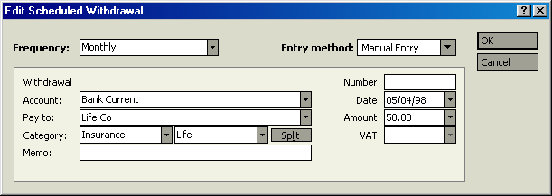
Life Company
Premium Amount
Enter Date Policy Started

Account Paying Premium
When all these fields have been completed Click OK. You will now be returned to the Bills section of Money. If the Endowment policy start date is dated prior to the set up of Money there may now be a number of payments to be entered.

Step 4:
The premiums for the policy are being paid, the accounts have been set up, but at the moment we do not have any monies in the accounts we have set up. What is needed is a recurring payment into the “Life Company Value Cash Account” To do this select: “Bills” from the white coloured tool bar, that is positioned in the third line down from the top of the Money screen. Click New Bill
- A new field will appear entitled “Create New recurring payment” In this field select Deposit and Click Next Click Next A new field will appear titled “Edit Scheduled Deposit”
Please see below for details with regard to entering information into “Edit Scheduled Deposit”
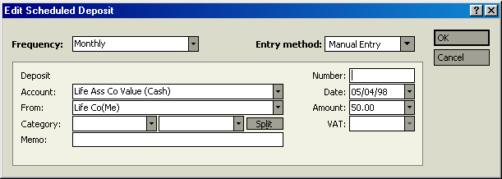
Make Sure Frequency is The Same As Premium Payment
Leave This Set At Manual Entry
Money is Deposited into Life Company Life Value Cash Account
Input Money User Name As Source of Money This can then be used for other Accounts
Make Sure Amount Is The Same As Premium Being Paid
Make Sure Date is Set at The Same Date As The Start Of Both Premium & Policy Dates

When all of these areas have been completed Click OK. A further field will appear that looks like:
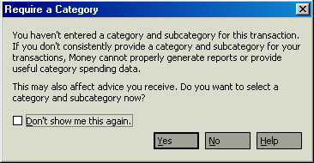
Put a tick in the box by “Don’t show me this again” and then Click NO
As previously mentioned if the first payment date occurred some time ago there will now be some payments to enter in Bills.

Step 5:
Because we now have a premium that is being paid in and out they are cancelling each other out. Therefore the Reports area and the Life Company Investment Cash Account need to be customised to reflect this.
To close and customise the account and reports follow these steps:
- From Account Manager select the Life Company Cash Account and Double Click to enter the account.
- Once in the account select and Click on details that is positioned in the dark vertical band on the left hand side of the screen.
- In Details place a tick in the small box next to “Account is Closed”.
- Click on Reports from the toolbar with the white background.
- Click on “Spending Habits” and then slightly to the left “Where the Money Goes”.
- You may then see a Pie Chart, if so Click on Report on the bottom left hand side.
- You will now see a Report as pictured below:

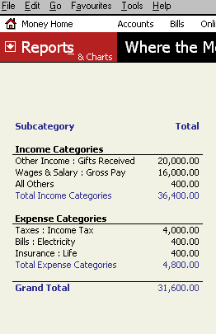
These Entries Are Both For The Same Life Cover Payment So Reports Must Be Customised So That “All Others” Is Not Shown
To amend this entry Click On customise which can be found offset to the right at the bottom of the Money Screen. A new field will appear which will enable reports to be customised as detailed below:
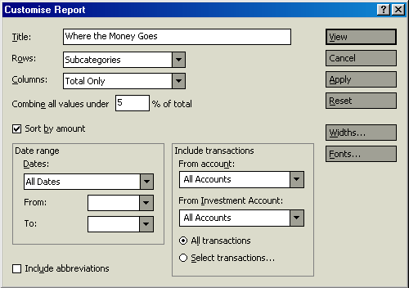
1. Make Sure ALL DATES Is Selected
2. Initially Select
ALL ACCOUNTS
3.Click On SELECT TRANSACTIONS
After following the above steps in order a new field will appear as detailed below:
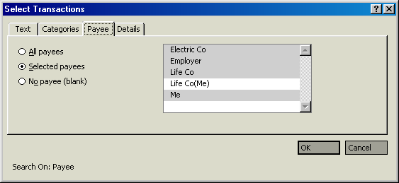

1. Select Payee Tab
2.Click On Premium Replacement Details Which Will then no Longer Appear Greyed Out
3.Click OK
You will then be returned to the previous screen where you will have to Click On the “View” button to finish the customisation.
The Report Screen will then look like this:
- 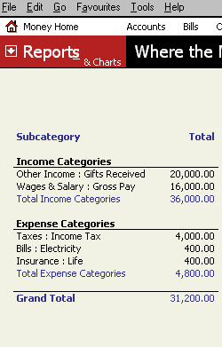
This Amount Is Now Only Shown Once

Step 6:
Having completed the previous steps it is now necessary to customise the reports to also exclude the “Life Company Investment Account” This has to be done, because the value for the unit linked endowment is already accounted for with the “Life Company Asset Account”.
To customise these accounts in reports follow these steps:
- In Reports select the “Net Worth Over Time Report”.
- You may then see a Pie Chart, if so Click on Report on the bottom left hand side.
You will now see a Report as pictured below:
- 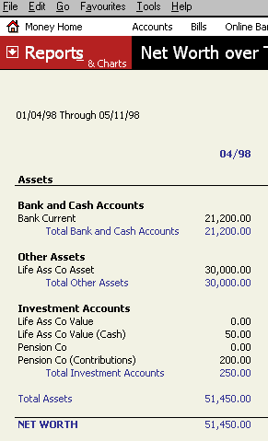
This Is The Value The Unit Linked Life Policy Will Pay Unless Or Until The Life Company Investment Account Value Equals Or Exceeds The Value Of This Asset .
(At That Time This Account Can Be Deleted)
Until The Joint Value Of These Accounts Exceeds The Value Of The Life Company Asset Account These Accounts Must Remain Hidden In Reports Or They Will Falsely Add To The Total Value Of The Money Users Assets
- Select “Customise” and you will then see the following screen:
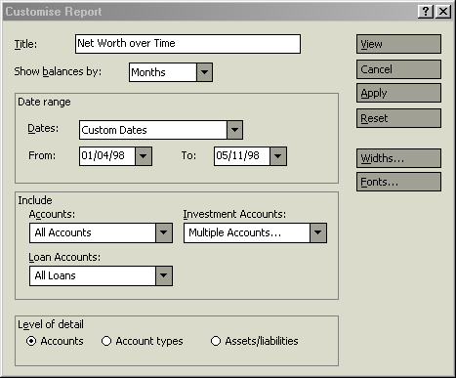

Click On Life Company Investment Which Will then no Longer Appear Greyed Out
In Customise Select Multiple Accounts
You will then see the following screen:
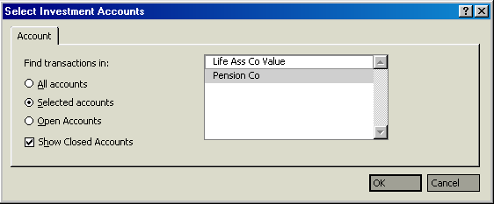
Remove Tick From Show Closed Accounts
Click On OK
The “Net Worth Over Time Report” will then look like:
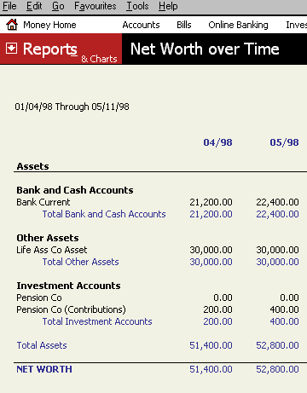
True Value Of Accounts Now Being Shown
Life Company Accounts No Longer Shown

Step 7:
As far as the Money user is concerned this is probably the most important step. With the “Life Company Asset Account” showing the value either until the “Life Company Investment Account” and its associated cash account reaches a value that exceeds that of the “Life Company Asset Account” (At which time the previously mentioned asset account can be deleted), or upon the Money users death. This step shows the value of the policy if surrendered early or if in the event of good investment returns the value exceeds that of the “Life Company Asset Account” at which time as previously mentioned the “Life Company Asset Account” can be deleted.
To enter details into the “Life Company Investment Account” we need to know the following:
- The name of the fund or funds selected as areas for investments.
- The purchase prices of the units for these funds. This can be obtained from Daily Newspapers, The Internet, and Television or from Statements provided by your Unit Linked Endowment policy provider.
An example of an Annual Statement is shown below:
Individual Fund Values
Date Plan First Started
Investment Funds
Price Per Unit
Value of policy

ANNUAL STATEMENT

STATEMENT DATE 08/03/97

MR CLIENT YOUR CONSULTANT IS
MICROSOFT MONEY AVENUE
ANYTOWN FOR ADVICE PLEASE CONTACT

ANYWHERE ANY LIFE COMPANY
UNIT TRUST ROAD
MSMONEY TOWN

POLICY PLAN DATE OF MONTHLY DEATH
NUMBER NAME ISSUE PREMIUM BENEFIT

151-206694-22 ENDOWMENT 04/04/91 £40.00 £28,513

UNITS ALLOCATED UNIT ACCOUNT UNIT PRICE FUND VALUE
17.784 2ND MANAGED £4.124 £73.34
36.864 2ND MANAGED FND 4 £1.989 £73.32

POLICY VALUE ON 08/03/97 £146.66

To enter the details for the previously shown statement the Money user should:
- From Account Manager, select and enter the “Life Company Investment Account”
- Click On the “New” button which is positioned on the left lower side of the screen.
The details from the previously shown Unit Linked Endowment Statement can be entered as shown below:
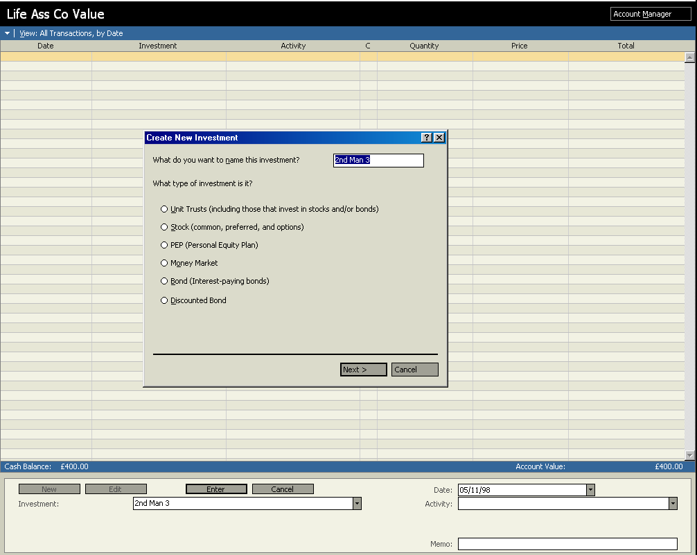
Input Fund Name
After Entering Fund Name The “Create New Investment” Field Will Appear. Select “Unit Trusts”
Enter Date Units Purchased
When Completed Click On Next
When this is completed a new field will appear, that will ask for the “Symbol of your Unit Trust”. It is unlikely that a Money User will be able to obtain symbols for unit linked policies at this time so leave this field blank. As for all intensive purposes the proceeds from an endowment are tax free (See Overview Endowments Page 15) place a Tick in the box by “Tax Exempt” and then Click on Finish.
After clicking on finish you will be given a number of options from the “Activity” field, select “Buy” and enter the information as detailed below:

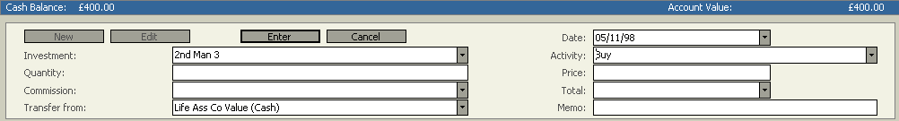
Purchase Date
Purchase Price
Transferred From Cash Account
When All Details Input Click On Enter
The Money Screen will appear as detailed below:
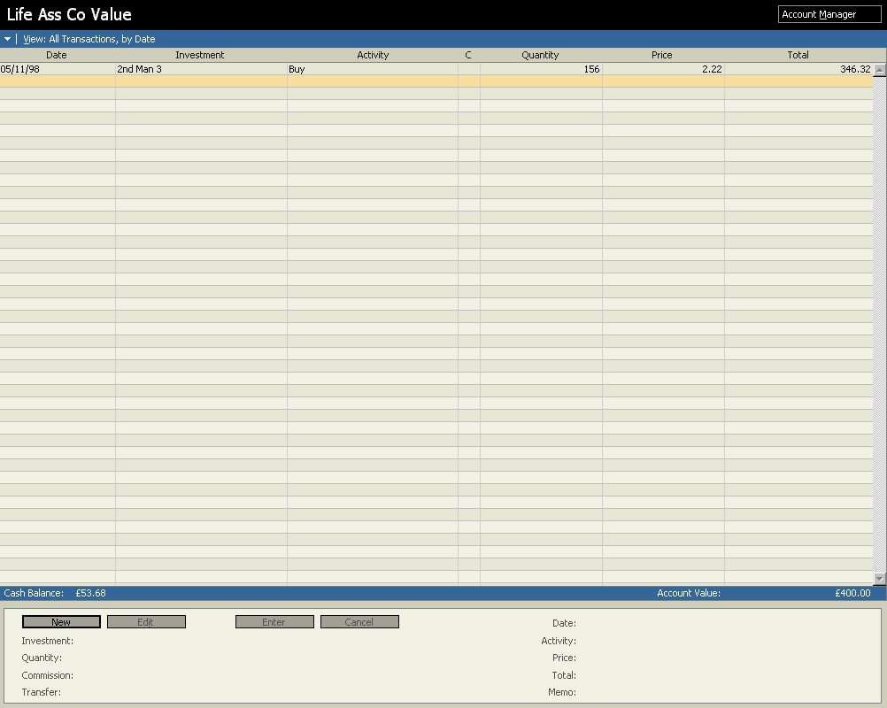
Total Account Value (Inclusive Of Cash Account)

Is Shown Here
All The Details Just Entered Are Recorded Here
If there is more than one fund repeat this process for each fund.
It is recommended that once a Money user has elected a method for updating their unit prices that they stick to one method.

Low Cost Whole of Life
The steps for setting up this type of life policy are basically the same as With Profits Endowments.

Step 1:
- From Account Manager open a new account. In the “Bank or Financial Institution” field input the name of the Assurance Company that the Whole of Life Policy has been taken out with. Click Next
- In the “What kind of account would you like to set up at………....” Select “Asset”. Click Next
- Name the account after the Life Assurance Company from who the product was purchased and add “Bonuses” to the end of the company name, then enter the date that the policy first started. Click Next
- Under “What is the value of this asset ?” input the Whole of Life sum assured (see Illustration example over). I.e. £8,090 in “What is the currency for this account ?” the base currency should already be input. Click Next
- In “would you like to associate a loan with the asset…….” Choose “No”. Click Next

Step 2:
- Select “I have other accounts at this bank” and again under “What kind of account would you like to set up at………....” Select “Asset”. Click Next
- Name the account after the Life Assurance Company from who the product was purchased and add “Life Cover” to the end of the company name. Enter the same date as was entered in step 1. Click Next
- Under “What is the value of this asset ?” input the life assurance value of the policy less the guaranteed sum assured (see Illustration example over) I.e. £100,000 minus £8,090. Click Next
- In “would you like to associate a loan with the asset…….” Choose “No”. Click Next
- Select “I have no other accounts at this bank”. Click Next. Click Finish

Step 3:
- Upon receipt of the annual statement, the bonus declared should be added to the account set up in step 1 (Life Assurance Company Bonus) and subtracted from the account set up in step 2 (Life Assurance Company life Cover).
- By using the above 3 steps the true value of the policy will be maintained in Money. If the policy holder dies prior to the maturity of the plan, the total value of the 2 accounts will be the amount paid by the assurance company and upon maturity of the policy the “Life Assurance Company Life Cover” account should be at nought and can then be deleted.

Premiums
The annual or monthly premiums should be entered via Bills with the Categories Insurance and Life selected.

An example of an illustration/statement.

Illustration for Low Cost Whole Life

20-Oct-98

Client Details:
############ Date of Birth 13/07/1967

Life Details:
Male Non-Smoker Age not over 31 years and 06 months

Initial Sum Assured

Selected Term: 46 years

Benefit:
Whole Life Sum Assured £8,090
Life Cover

Decreasing Term Assurance Initial Sum Assured £91,910

Total Initial Sum Assured payable on
death within the term. £100,000

IN THE EVENT OF A DEATH CLAIM IN THE FIRST 10 YEARS OF THE POLICY THE AMOUNT PAYABLE IS GUARANTEED TO BE NO LESS THAN THE TOTAL INITIAL SUM ASSURED

Premium Details:
Monthly Premium of £42.25 payable for 46 years, followed by £18.30 thereafter.
Potential Benefits At 5%, 7.5% & 10% Growth

What your claim value might be after 44 years:

If investments grew at 5.0% a year the claim value would be £47,800
If investments grew at 7.5% a year the claim value would be £74,400
If investments grew at 10.0% a year the claim value would be £128,000

Continued….
What your claim value might be after 46 years:

If investments grew at 5.0% a year the claim value would be £45,100
If investments grew at 7.5% a year the claim value would be £74,700
If investments grew at 10.0% a year the claim value would be £136,000

These figures are only examples and are not guaranteed - they are not minimum or maximum amounts. What you will get back depends on how your investments grow.

You could get back more or less than this.

All insurance companies use the same rates of growth for illustration but their charges vary.

Do not forget that inflation would reduce what you could buy in the future with the amounts shown.

How much will the advice cost?

The amount will depend on the size of the premium and the length of the policy term. It will be paid for out of the deductions.

THE EARLY YEARS

WARNING - if you cash during the early years you could get back less than you have paid in.

The last two columns assume that investments will grow at 7.5% per year.

At end Total Total actual Effect of What you
of year paid in deductions deductions might get
to date to date to date back
£ £ £ £
1 507 397 397 129
2 1,014 841 871 222
3 1,521 1,260 1,360 339
4 2,028 1,690 1,880 469
5 2,535 2,080 2,420 643

THE LATER YEARS

At end of Total Total actual Effect of What you
year paid in deductions deductions might get
to date to date to date back
£ £ £ £
10 5,070 3,900 5,570 1,880
20 10,140 6,100 14,800 8,020
30 15,210 11,200 37,400 17,000
40 20,280 19,600 88,900 30,900
44 22,308 24,200 123,000 38,500

What are the deductions for?

The deductions include the cost of life cover, commissions, expenses, charges, any surrender penalties and other adjustments.

The last line in the table shows that over the period illustrated the effect of the total deductions could amount to £123,000.

Putting it another way, leaving out the cost of life cover, this would have the same effect as bringing the investment growth used from 7.5% a year down to 6.5% a year.

Unit Linked Whole Of Life
The steps for setting up Unit Linked Whole of Life Policies are identical to the steps for setting up Unit Linked Endowments. However the Money user should bear in mind the following:
- Unit Linked Whole of Life Policies are normally subject to a review, starting at either 5,or 10 years and then normally every 5 years thereafter. Depending on the performance of the plan the policy owner could be subject to a premium increase.
- This type of Policy normally incurs extra charges in the first few years, so the tracking of this type of policy for the first few years should only be from the annual statements provided.
Over are some examples of Annual Statements and Policy Schedules that provides information on Unit Linked Whole of Life Policies:
An example of an illustration/statement.
Individual Fund Values
Investment Funds
Price Per Unit
Value of Policy
ANNUAL STATEMENT

STATEMENT DATE 08/03/98

MR MS MONEY USER
MICROSOFT MONEY AVENUE
ANYTOWN YOUR CONSULTANT IS

ANYWHERE ANY LIFE COMPANY
UNIT TRUST ROAD
MSMONEY TOWN

POLICY PLAN DATE OF MONTHLY DEATH
NUMBER NAME ISSUE PREMIUM BENEFIT

151-206694-22 WHOLE OF LIFE 04/04/91 £33.00 £30,000

UNITS ALLOCATED UNIT ACCOUNT UNIT PRICE FUND VALUE
29.492 2ND MANAGED £4.080 £120.33
93.124 2ND EUROPEAN £1.989 £124.32
Amount Of Units Allocated To Each Fund

POLICY VALUE ON 08/03/97 £244.65

If the procedure for the set up of unit linked policies is followed, the above statement contains all the information required to update the value of their policy.

Term Assurance Policies
Of all the Life Assurance and Investment products available, Term Assurance policies are the easiest to enter into Money:
To enter a Term Assurance product into Money use the following steps:
- From Account Manager open a new account. In the “Bank or Financial Institution” field input the name of the Life Assurance Company that the endowment has been taken out with. Click Next
- In the “What kind of account would you like to set up at………....” Select “Asset”. Click Next
- Name the account after the Life Assurance Company from who the product was purchased and add “Term Assurance” to the end of the company name, then enter the date that the policy first started. Click Next
- Under “What is the value of this asset ?” input the Life Cover amount (see Illustration example over). I.e. £100,000 in “What is the currency for this account ?” the base currency should already be input. Click Next
- In “would you like to associate a loan with the asset…….” Choose “No” . Click Next
Important Notes

Mortgage Protection & Decreasing Term Policies
These policies decrease in value by set amounts, so a table showing how much the life policy is decreasing by is required, so that the money user can deduct this amount from the Life Company Term Assurance Asset Account on the dates that the value of the policy decreases. A table for the decreasing amounts should be available upon asking from the Life Assurance Company.
With the Mortgage Protection policy, a “Rule of Thumb” guide would be to decrease the policy in line with the Repayment Mortgage the Life Policy was taken out to protect.

Family Income Benefit
This type of policy pays out a monthly or annual amount, therefore the total amount of the asset recorded should be reduced by this monthly or annual amount each month.
To arrive at the original total asset multiply the income by the amount of months or years the policy will cover from start to finish.

Permanent Health Insurance
This type of policy pays out a monthly amount, therefore the total amount of the asset recorded should be reduced by this monthly amount each month.
To arrive at the original total asset multiply the monthly income by the amount of months the policy will cover from start to finish.
If you do not know when the monthly income will end, take your best guess.
.
An example of an illustration/statement.

Illustration for Term Assurance

20-Oct-98

Client Details:
##### Date of Birth 13/07/1967

Life Details:
Male Non-Smoker Age not over 31 years 4 months

Policy Term: 15 years
Term Of Plan, Upon Maturity Asset can Be Deleted

Benefit:

Sum Assured payable on death within the term of the policy or when a claim for Terminal Illness Benefit is accepted by CGU.
£100000
Life Cover

Premium Details:

Monthly Premium payable for 15 years £ 10.60

WARNING - this contract has no cash-in value at any time.

How Much Will The Advice Cost?

The amount will depend on the size of the premium and the length of the policy term. It will be paid for out of the deductions.

Unit Trusts/ OEICs
Unit Trusts/ OEICs can be paid for by single investments or on a regular payment basis. When setting up an investment in Unit Trusts/ OEICs the amount to be paid is set up as detailed below:

Step 1:
- From Account Manager open a new account.
- In the “Bank or Financial Institution” field input the name of the Company that the Unit Trusts/ OEICs are being purchased from. Click Next
- In the “What kind of account would you like to set up at………....” Select “Investment”. Click Next
- Name the account after the Company from who the Units are being purchased. Click Next
- In “Are the investments in this account tax exempt ?” Click No. Click Next
- Enter 0(nought) in “Enter the estimated value of the investments in this account not including any cash balance”. Select “Yes the account does have a place to store uninvested cash” Click Next
- Enter 0 (nought) in “How much do you have in the cash account” The currency should already be selected. Click Next
Select “long term savings and Investments” Click Next. Click Next

Important Note
When ever setting up an investment account, never input a value into either the investment or the cash account until after the accounts have been set up. This will ensure that the graphs and charts in reports are accurate.

Step 2:
- To set up the investment amount select “Bills” from the white coloured tool bar, that is positioned in the third line down from the top of the Money screen.
- Click New Bill a new field will appear entitled “Create New recurring payment” In this field select Transfer and Click Next Click Next
- A new field will appear titled “Edit Scheduled Transfer”
Please see over for details with regard to entering information into “Edit Scheduled Transfer”

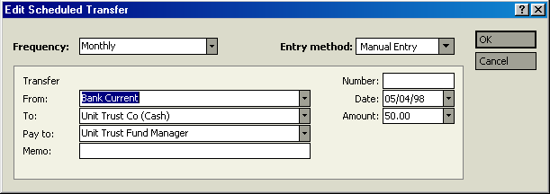
Date Investment Started
Transfer To Cash Account
Company Investment Is With
Investment Amount

Step 3:-
To enter details into the “Unit Trust Investment Account” we need to know the following:
- The name of the fund or funds selected as areas for investments.
- The purchase prices of the units for these funds. This can be obtained from Daily Newspapers, The Internet, and Television or from Statements provided by the company managing your Unit Trusts/ OEICs.
To enter the details for the purchase of Unit Trusts/ OEICs the Money user should:
- From Account Manager, select and enter the “Unit Trust Investment Account”
- Click On the “New” button which is positioned on the left lower side of the screen.
The purchase details can be entered as shown below:
After Entering Fund Name, The “Create New Investment” Field Will Appear. Select “Unit Trusts”
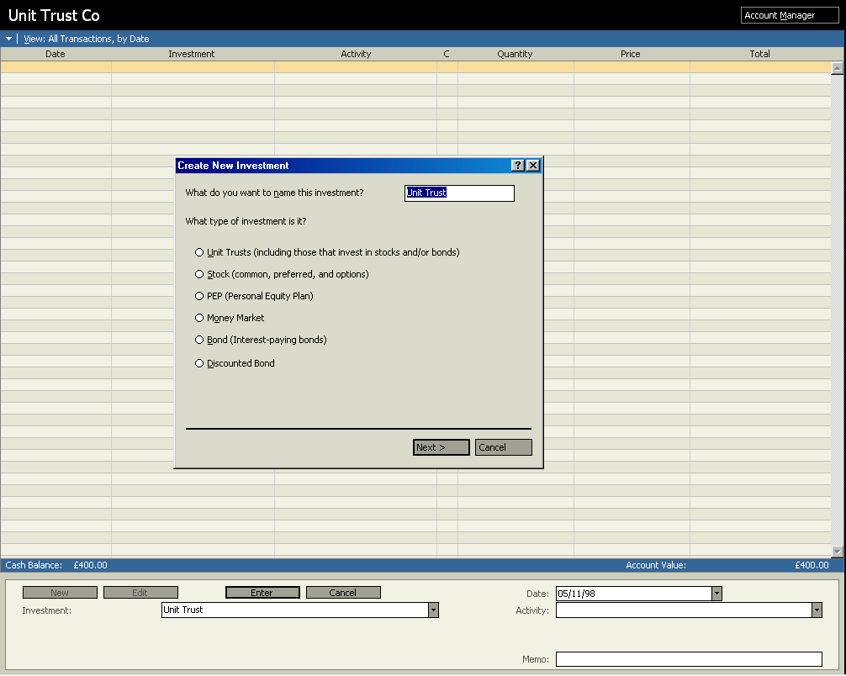
Input Fund Name
When Completed Click On Next
Enter Date Units Purchased
When this is completed a new field will appear, that will ask for the “Symbol of your Unit Trust”. It is unlikely that a Money User will be able to obtain symbols for Unit Trusts/ OEICs policies at this time so leave this field blank.
After clicking on finish you will be given a number of options from the “Activity” field, select “Buy” and enter the information as detailed below:
Purchase Date
Purchase Price

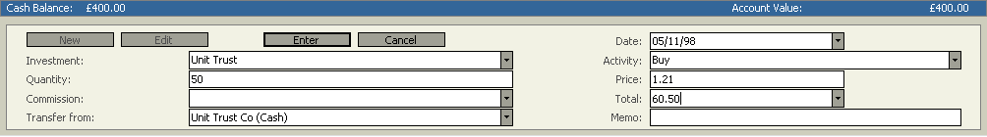
When All Details Input, Click On Enter
Transfer From Cash Account
The Money Screen will appear as detailed below:
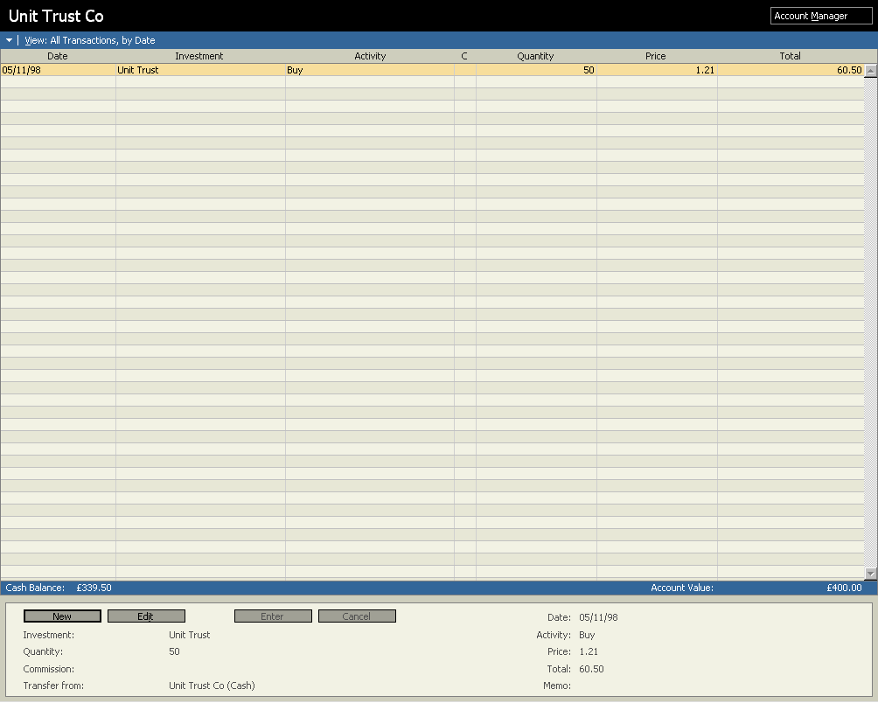
Total Account Value (Inclusive Of Cash Account)
Is Shown Here
All The Details Just Entered Are Recorded Here
If there is more than one fund repeat this process for each fund.
It is recommended that once a Money user has elected a method for updating their unit prices that they stick to one method.

Personal Equity Plans
With Personal Equity Plans (PEPs) there are 2 options for how the account is set up. Initially an account for a PEP or a relevant Individual Savings Account is set up identically to a Unit Trust which is detailed below:

Step 1:
- From Account Manager open a new account.
- In the “Bank or Financial Institution” field input the name of the Company that the PEP is being purchased from. Click Next
- In the “What kind of account would you like to set up at………....” Select “Investment”. Click Next
- Name the account after the Company from who the PEP is being purchased. Click Next
- In “Are the investments in this account tax exempt ?” Click YES. Click Next
- Enter 0 (nought) in “Enter the estimated value of the investments in this account not including any cash balance”. Select “Yes the account does have a place to store uninvested cash” Click Next
- Enter 0 (nought) in “How much do you have in the cash account” The currency should already be selected. Click Next
Select “long term savings and Investments” Click Next. Click Next
Important Note
When ever setting up an investment account, never input a value into either the investment or the cash account until after the accounts have been set up. This will ensure that the graphs and charts in reports are accurate.

Step 2:
- To set up the investment amount select “Bills” from the white coloured tool bar, that is positioned in the third line down from the top of the Money screen.
- Click New Bill a new field will appear entitled “Create New recurring payment” In this field select Transfer and Click Next Click Next
- A new field will appear titled “Edit Scheduled Transfer”
Please see over for details with regard to entering information into “Edit Scheduled Transfer”

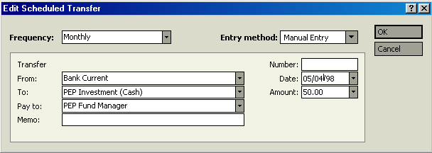
Select How Often Investment Made With a Single Amount Select Once
Account Paying Investment

Step 3:-
To enter details into the “PEP Investment Account” we need to know the following:
- The name of the fund or funds selected as areas for investments.
- The purchase prices of the units for these funds. These can be obtained from Daily Newspapers, The Internet, and Television or from Statements provided by the company managing your PEP.
A PEP can be tracked in the following two ways:
- Twice yearly upon receipt of the PEP Statements
- Tracked exactly the same as a Unit Trust/ OEIC
To enter the details for the investment into a PEP the Money user should:
- From Account Manager, select and enter the “PEP Investment Account”
- Click On the “New” button which is positioned on the left lower side of the screen.
The purchase details can be entered as shown below:
Input Fund Name
After Entering Fund Name The “Create New Investment” Field Will Appear. Select “Unit Trusts” or “Stock” If You Wish To Track All The Areas That Your PEP Is Invested Into If You Just Wish To Track The Value Select PEP
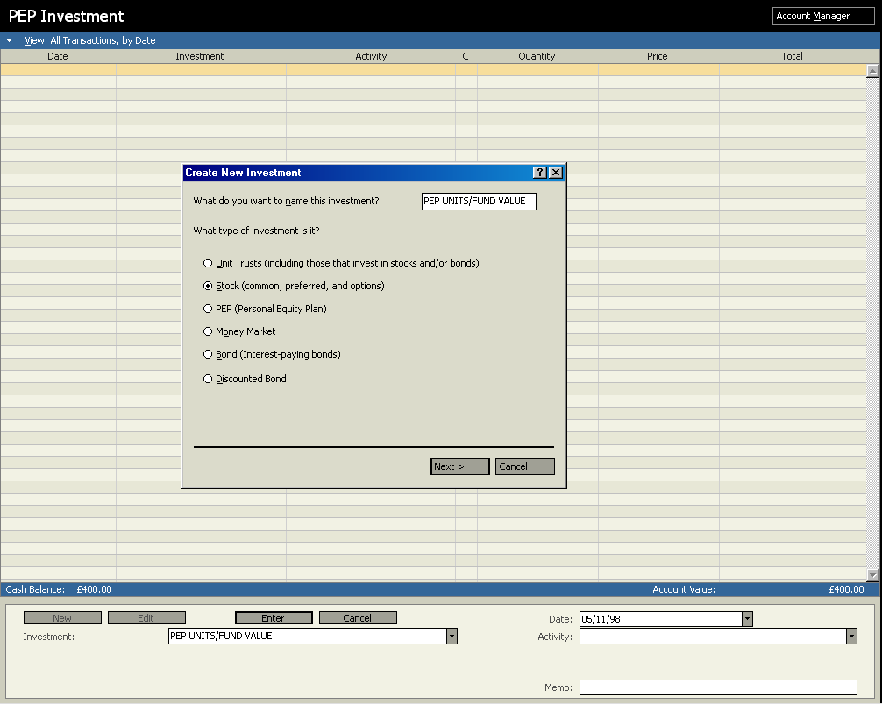
When Completed Click On Next
Enter Date Units Purchased
When this is completed a new field will appear, that will ask for the “Symbol of your Unit Trust or PEP”. It is unlikely that a Money User will be able to obtain symbols for Unit Trusts/ OEICs or PEPs at this time so leave this field blank.
How the details of the PEP are entered depends on which choice was selected in the “Create New Investment” field as shown over.

PEP With Unit Trust Option Selected
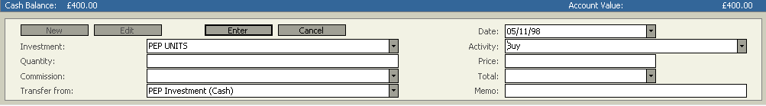
PEP Fund
Amount Of Units
Date Units Purchased
Select Activity BUY
Price Of Units
The choices and options available are identical to the purchase of a direct investment into Unit Trusts/ OEICs.

PEP With PEP Option Selected
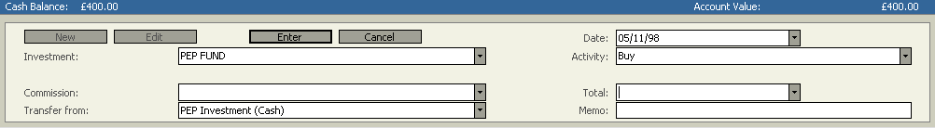

With The PEP Option In “Create New Investment” Selected There Is Only The Choice To Enter The Actual Value Not The Amount Of Units Purchased
If tracking a PEP using the Unit Trust or Stock Options the account register will look like:

Date Units Or Shares Purchased

Investment Fund

Details Of Activity Such As Buy Or Sell Units Or Shares

Amount Of Units Or Shares Purchased Or Sold
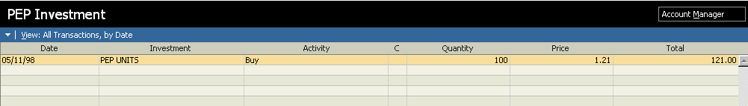

Price Of Units Or Shares

Total Value
When tracking a PEP having selected the PEP option in “Create New Investment” will mean that the account register looks like:

Total Value Is Shown But Not Quantity Or Price
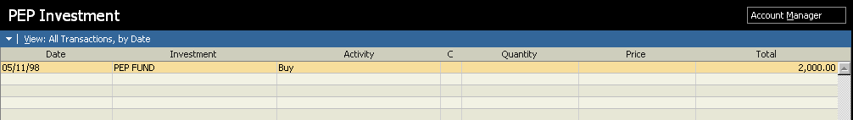

Date Units Or Shares Purchased

Name Of PEP

The Activity Choices Are Reduced If PEP Selected
Although it is not recommended it is possible to mix the PEP, Unit Trust and Stock options, within one investment account.
An example of a single investment PEP statement is shown over:
PEP STATEMENT Page 1

##############################
###############
###############
############
###############
#################
########################
########################

########## Client Name: ##############
Microsoft London Client Account Number: 4547004
Statement Number: (Amalgamated)
Statement Date: 28th April 1998

GENERAL PEP VALUATION AS AT 28th April 1998
DESCRIPTION OF SECURITY | NUMBER OF UNIT/SHARES | UNIT/SHARE PRICE | VALUE  £
Perpetual High Income Fund | 4,814.40 | 169.320 | 8,151.74
Cash |  |  | 10.06
 | TOTAL VALUE |  | 8161.80

Shares and investment trusts are valued at their middle-market price and Unit Trusts/ OEICs are valued at the latest available selling price. The number of units/shares shown above are held in safe custody by Perpetual Portfolio Management Limited.

SUBSCRIPTION AND WITHDRAWAL SUMMARY BY TAX YEAR
TAX YEAR | TOTAL  SUBSCRIPTIONS  £ | TRANSFERS IN FROM OTHER PLAN MANAGERS  £ | WITHDRAWALS  £ | REGULAR PAYMENTS OUT OF PLAN  £
1997/98 | 6,000.00
TOTALS | 6,000.00 | NIL | NIL | NIL

WITHDRAWALS are normally made following a written request, and may have involved the sale of some of your holdings or use of available plan cash.

REGULAR PAYMENTS are made direct to your bank or building society account. They usually contain any available income in your plan. Some payments may be settled by the sale of holdings.

PEP STATEMENT Page 2
Client Name: ##########
Client Account Number: ########
Statement Number: ####### (Amalgamated)
Statement Date: 28th April 1998

TRANSACTION DETAILS FOR THE PERIOD 9th April 1997 TO 28th April 1998

DATE | TRANSACTIOnN | SECURITY | NUMBER OF UNITS/ SHARES | PRICE | CASH RECEIPTS/ PAYMENTS £ | CASH BALANCE £
OPENING CASH BALANCE AT 9th April 1997 |  |  |  |  |  | 0.00
09/04/97 | Receipt From Client | Cash |  |  | 6000.00 | 6000.00
09/04/97 | Purchase Of Units | Perpetual High Income Fund | 4684.61 | 134.820 | 6315.79- | 315.79-
09/04/97 | Discount | Perpetual High Income Fund |  |  | 315.79 | 0.00
31/08/97 | Net Dividend | Perpetual High Income Fund |  |  | 95.92 | 95.92
31/08/97 | Foreign Income Dividend | Perpetual High Income Fund |  |  | 11.27 | 107.19
21/10/97 | Income Tax Reclaim | Perpetual High Income Fund |  |  | 11.59 | 130.78
24/10/97 | Re-Investment Of Income | Perpetual High Income Fund | 77.42 | 153.430 | 118.78- | 12.00
30/11/97 | Interest Received | Cash |  |  | 1.12 | 6.27

Amount Of Units Purchased

Sum Invested

A Guide to some of the language used within PEP and Unit Trust statements
Contribution The amount of payment received
Charge The amount of the initial charge deducted from a contribution
before units are purchased for a plan or the charge deducted
when a plan’s investments are switched from one unit trust
option to another
Bought Units purchased for a plan
Regular purchase Units purchased for a plan by monthly contributions.
Sold Units sold from a plan.
Withdrawal The amount of cash withdrawal from a plan.
Distribution received The amount of income generated from a unit holding and credited to a plan.
Distribution paid out The amount of an income payment received from a plan
Distribution reinvested Units purchased for a plan with income that has been credited.
Tax credit due The amount of tax credit associated with a distribution.
Tax credit advance The amount of tax credit which has not yet been reclaimed from the Inland
Revenue but which has been pre-funded and paid in advance with
an income payment.
Tax credit received The amount of a tax credit that has been reclaimed from the Inland Revenue.
Tax credit reinvested Units purchased for a plan with the tax reclaimed from the Inland Revenue.
Tax credit refund This is normally the reimbursement of a “Tax credit advance” after the
pre-funded tax credit is reclaimed from the Inland Revenue. Alternatively this
may show the reimbursement to the Inland Revenue of tax credits to which a plan was not entitled.

Single Premium Investments
Are tracked identically to Unit linked or With profits type policies the only difference being that the premium is only paid once.

Pensions And Set Up Of Paycheque In Bills
There is the facility to set up Pension Accounts within Money. The Pensions account is also set up in a similar fashion to other investment accounts already previously mentioned and depends on whether the account is With Profits or Unit Linked.
With Pensions the following must be taken into account:
A Pension account can be set up through the Bills section of Money, when the Money user is setting up the deposit of their salary into their account on a regular basis as is shown below and over:
- Select “Bills” from the white coloured tool bar, that is positioned in the third line down from the top of the Money screen.
- Once you are in the Bills section. Click New Bill that is positioned at the lower left of the screen
- A new field will appear entitled “Create New recurring payment” In this field select Deposit and Click Next Click Next A new field will appear titled “Edit Scheduled Deposit” choose “Pay Cheque” as the Category and you will then see:
Please see below for details with regard to entering information into “Edit Scheduled Deposit”
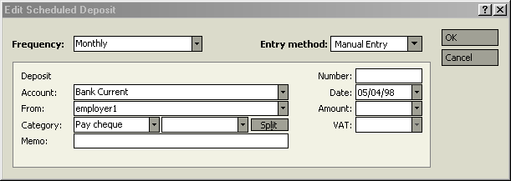
Select Paycheque As Category

A field entitled “New Pay Cheque” will then appear:
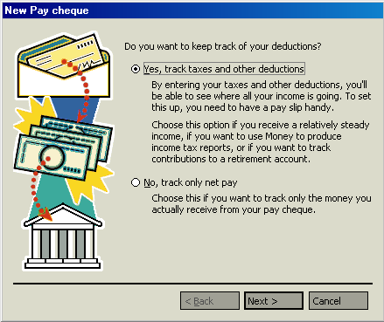

Select Next
Say “Yes, Track Taxes And Other Deductions
- You will then see:
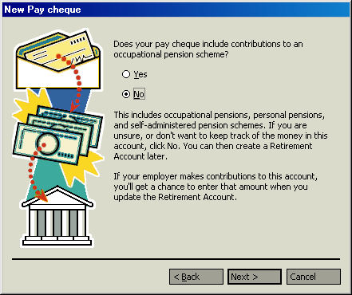
Say “Yes”

Select Next
After saying “Yes” and selecting “Next” you will then see:
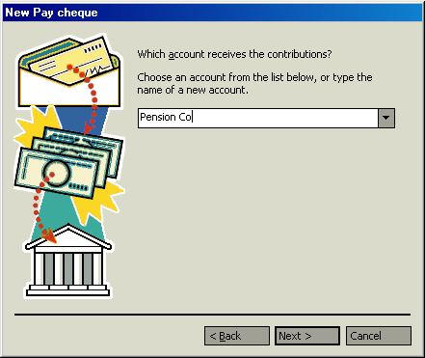

You Can Either Select An Existing Account Or Create A New One.
Once the pension Accounts have been created the Money user is then asked “Does your pay cheque include contributions to a savings account”. Answer “Yes” or “No” to this question, if you answer “Yes” you will asked to either set up a new savings account or to direct the savings contributions to an existing account. After which Click Next Click Next and you will then see the following field:
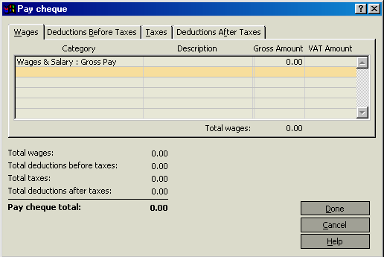

Enter Gross Salary And Then Select “Deductions Before Taxes Tab
You will then see:
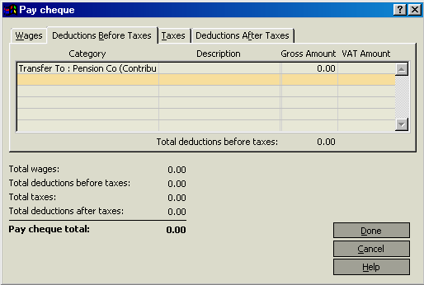

Enter Pension Amount on Pay Slip And Select “Taxes” Tab
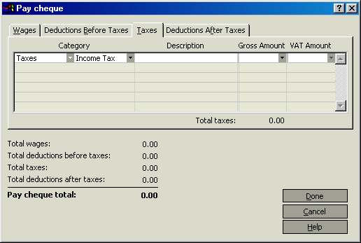

Enter Usual Amount Of Income Tax Deducted

If the Money user has a savings scheme that is deducted select the “Deductions After Taxes”
Tab and enter the details.
Pension Notes
Because of the different types of Pension Scheme available, the following applies:
- Do not enter any employers Pension contribution in “Pay Cheque” as this will have the effect of increasing the Money users salary
- If the Pension is an occupational pension scheme the full gross amount of pension contribution will be stated on the pay slip and can be entered as a pension contribution in Pay Cheque.
- Some Pensions are what is termed as “Non Contributory” the “Ministry of Defence” being an example and no pension contribution should be entered in “Pay Cheque”. If the employers Pension contribution is known this can entered into a Pension account that has been created outside of Pay Cheque.
- If the Money user has either a Personal Pension or a Group Personal Pension that is being deducted from their salary this can be entered into “Pay Cheque”. However this amount will be the net amount and the difference between the net and gross amount will have to be added as additional payments from within Money.
Pension Contribution Notes
- If the Pension account has been set up through Pay Cheque then all Pension contributions that have been set up in Pay Cheque will be automatically credited to the Pension “Cash Account”.
- Pension contributions from an employer can be entered into the same Pension cash account as the Money user’s own Pension contributions or they can be tracked separately in a new Pension account.
- If the employers Pension contributions are being tracked separately then the categories for this account can be set up automatically by entering the “Details” section of the Pension account intended for the employers Pension contributions and placing a tick in the box next to “Employer Pension Contributions”
- If the Pension is a “With Profits” type contract, the best way to track the Pension is the value only.
- If the Pension is a “Unit Linked” type contract then all Unit purchase details should be entered in “Pension Investment” register in the same way as all other unit linked type funds that have been previously mentioned, with the funds coming from the Pension “Cash” account.
The following pages contain examples of a Pension Illustration:

An example of an illustration/statement.

Personal Pension Plan Illustration

20-Oct-98

Client Details:
###### Date of Birth 13/07/1967
Male Non-Smoker Age not over 31 years and 4 months

Selected Pension Age : 65 years

Options:

Waiver of Contributions has been chosen, and assumes that the client is in occupation class 1 or 2.

Death Benefit:

On death before retirement the value of units will be payable.

Total Contribution

Contribution Details:
Regular
Member's Contributions
Gross Monthly Contribution £100.00
Tax Relief at source (23.%) £23.00

Net Monthly Contribution £77.00

The monthly contributions above are payable to CGU for 33 years and 9 months.

This illustration assumes that regular contributions are invested as follows:

Unit Linked 100%

How much will the advice cost?

Your Financial Adviser will give you details about the cost. The amount will depend on the size of the premium and the length of the policy term. It will be paid for out of the deductions.

Continued….
What you might get back at Selected Pension Age:

If your investments grew at a rate of 6.0% each year:
Your fund would be worth £101,000
Based on projected annuity rates, this would give you:
A level pension of £9,290 p.a.
OR
Tax free cash of £25,400
and
A reduced level pension of £6,960 p.a.

If your investments grew at a rate of 9.0% each year:
Your fund would be worth £187,000
Based on projected annuity rates, this would give you:
A level pension of £20,300 p.a.
OR
Tax free cash of £46,800
and
A reduced level pension of £15,200 p.a.

If your investments grew at a rate of 12.0% each year
Your fund would be worth £358,000
Based on projected annuity rates, this would give you:
A level pension of £45,200 p.a.
OR
Tax free cash of £89,500
and
A reduced level pension of £33,900 p.a.

These figures are only examples and are not guaranteed - they are not minimum or maximum amounts. What you will get back depends on how your investments grow.

You could get back more or less than this.

All insurance companies use the same rates of growth for illustrations but their charges vary. They also use the same rates to illustrate how funds may be converted into pension income.

Do not forget that inflation would reduce what you could buy in the future with the amounts shown.

Your pension income will depend on how your investments grow and interest rates at the time you retire.

The projected pensions shown above are payable by monthly installments in advance for life but will continue in any event for 5 years.

Regular Contributions

THE EARLY YEARS

WARNING - if you cash in during the early years you could get back less than you have paid in.

The last 2 columns assume that investments will grow at 9% per year.

At end Total Total actual Effect of What the
year paid in Deductions Deductions Transfer Value
to date to date to date might be
£ £ £ £
1 1,200 180 180 1,070
2 2,400 374 390 2,230
3 3,600 582 633 3,480
4 4,800 805 913 4,830
5 6,000 1,040 1,230 6,290

Continued….
THE LATER YEARS

At end Total Total actual Effect of What the
year paid in Deductions Deductions Transfer Value
to date to date to date might be
£ £ £ £
10 12,000 1,760 2,880 16,200
15 18,000 3,080 6,010 30,900
20 24,000 4,880 11,300 52,900
25 30,000 7,530 20,600 85,800
30 36,000 11,300 36,300 135,000
33 39,600 14,300 50,200 175,000
At Selected
Pen Age 40,500 15,300 54,500 187,000

What are the deductions for?

The deductions include waiver, commissions, expenses, charges, any transfer penalties and other adjustments.

The last line in the table shows that over the full term of the policy the effect of the total deductions could amount to £54,500.

Putting it another way, leaving out the cost of waiver this would have the same effect as bringing the investment growth used from 9% a year down to 7.9% a year.

What are the charges?

* The price at which you buy units is higher than the price at which you can cash in units. The difference, known as the bid/offer spread, is currently 5%.

* On Unit Linked Funds there is currently an annual management charge of 0.625% per year. The charge will be reflected in the unit prices.

* At the end of each policy year an additional management charge of 0.375% will be deducted by the cancellation of units purchased by regular contributions.

* The percentage of each contribution which is used to buy units is determined by the allocation rate. The allocation rate on your policy will be:
95.00% for each regular contribution

* The charge for waiver and the following administration fees will be deducted from your policy by the cancellation of units: A monthly fee of £2.50, which will be reviewed annually.

* Please note that charges may not remain at the current levels..

Loyalty Bonus

* Additional units will be credited to the policy on transfer, death or retirement, where regular contributions have been paid for at least 10 years.

How much will the advice cost?

The amount will depend on the size of the premium and the length of the policy term. It will be paid for out of the deductions.

TESSAs
Should be tracked as a Savings Plan, this should be set up from Account Manager using the following steps:

- From Account Manager open a new account.
- In the “Bank or Financial Institution” field input the name of the Bank or Building Society that the TESSA is being opened with. Click Next.
- In the “What kind of account would you like to set up at………....” Select “Savings”. Click Next
- Name the account after the Bank or Building Society from who the TESSA is being purchased. Click Next
- Select “Short Term Savings”. Click Next
- Enter the estimated value of the TESSA. The currency should already be selected. Click Next Click Finish

Stock & Shares
Shares are normally purchased through a Stockbroker and are generally classed as a higher risk investment. This type of investment is tracked identically to Unit Trusts/ OEICs.

Companies, names and data used in examples herein are fictitious unless otherwise noted. Information in this document is subject to change without notice.
This document is for informational purposes only. MICROSOFT MAKES NO WARRANTIES, EXPRESS OR IMPLIED, IN THIS DOCUMENT.
Copyright 1998 Microsoft Ltd. All rights reserved. Microsoft Ltd, Thames Valley Park, Reading RG6 1WG.

